WHERE TO FIND SOURCE (REFERENCING INFORMATION) | HOW RELIABLE IS THIS SOURCE? | HOW USEFUL IS THIS SOURCE?
The title is…...  The author’s name is….  The date of publication was….  The journal / magazine / website is called…..  The URL is…..  For AI sources, I have included a link/transcript of the original prompt/response conversation… | The person writing is/is not an expert and I know this because…..  I have compared this source with other sources in order to confirm (or question) its reliability…  The evidence suggesting this source is fact / speculation / opinion is… | This source gave me information about….  This source helped me to understand…..  This source may have limited usefulness because…
This is how a breadth traversal algorithm works. It was provided by Peter Symonds College on the behalf of the AQA exam board.  Here is the URL:  Algorithms T4 Graph traversal algorithms  (slides 27 to 38)  [1] | Given that both AQA and Peter Symonds College are well known and established institutions, I would say that this algorithm provided is accurate. Furthermore, I checked the internet and found other sources provided a similar algorithm:  Breadth First Search or BFS for a Graph | GeeksforGeeks  Depth First Search or DFS for a Graph - GeeksforGeeks  Therefore, I believe this source is factual.  [2] | This source allows me to understand a breadth first traversal. This will allow me to verify that the maze is connected. In graph theory, if a graph is connected, you can get to any node (point) from a certain node following a path. If the maze is connected then it is solvable. This means that I can now generate a random adjacency matrix representing a maze and verify that it is solvable. The limitation of this source is it only demonstrates the reliability of this algorithm on one graph.
This is how Prim’s minimum spanning tree algorithm works. It was provided by Peter Symonds College on the behalf of the OCR (MEI) exam board.  Here is the URL:  Minimum Spanning Trees Notes.pdf  (Page 3)  [3] | Given that both OCR and Peter Symonds College are well known and established institutions, I would say that this algorithm provided is accurate. Furthermore, I checked the internet and found other sources provided a similar algorithm:  Prim's algorithm in 2 minutes  Therefore, I believe this source is factual.  [4] | Once I have generated a random adjacency matrix, the maze it will represent will be unreasonably complicated. To make it more realistic, I will convert the graph into a minimum spanning tree, by removing most of the unnecessary arcs. Then I will randomly add a few arcs back to make the maze have loops (realism.) This is considered a standard maze generation technique.
This is how Dijkstra's algorithm works. It was provided by Peter Symonds College on the behalf of the OCR (MEI) exam board.  Here is the URL:  Shortest Paths Notes.pdf  [5] | Given that both OCR and Peter Symonds College are well known and established institutions, I would say that this algorithm provided is accurate. Furthermore, I checked the internet and found other sources provided a similar algorithm:  Dijkstra's Algorithm | Edexcel A Level Further Maths Revision Notes 2017  Therefore, I believe this source is factual.  [6] | This source allows me to understand Dijkstra's algorithm. This will allow me to make a program to solve any maze that I will generate and find the shortest path through that maze. This will be useful as a benchmark to compare the agents against. The limitation of this algorithm is it only finds the shortest path. The agents are however, completely uninformed on the structure of the maze so are unlikely to perfectly follow the shortest path (hence I will need to modify the programmed shortest path timing to account for this.)
This is the type of AI that I will be using to solve the maze. It was provided by Abid Ali Awan on Oct 27, 2022 on the behalf of datacamp.  Here is the URL:  An Introduction to Q-Learning: A Tutorial For Beginners | DataCamp  [7] | I checked Abid Ali Awan’s linkedin and it turns out he is a data scientist (Abid Ali Awan - KDnuggets | LinkedIn) therefore he most likely has good knowledge on AI. I checked the internet and found another source which explained the q-function in a similar manner:  What is Q-Learning (back to basics)  Therefore, there is a lot of evidence to suggest that this source is reliable.  [8] | This source allows me to understand the Q-Function. This will be the main program that will be responsible for realistically solving the maze like a person would solve the maze. This source is limited to the Q-Function and does not look further (potentially into the Deep-Q-Learning) but this should not be significant because I doubt I will be going any further than the tabular Q-Function in this project.
Here is the documentation for NumPy. According to Wikipedia, it was released in early 2005.  Here is the URL:  NumPy Documentation  [9] | This source is 100% reliable. This is because this source has been provided by the actual creators of the library that I will be using and so they will know their own code. | This is the library that I will be most likely using for handling the adjacency matrix containing the maze information. The documentation is very large to the point where it can be difficult to locate things that I need.
Here is the documentation for Gymnasium. It was released on 2022/09/13.  Here is the URL:  Gymnasium Documentation  [10] | This source is 100% reliable. This is because this source has been provided by the actual creators of the library that I will be using and so they will know their own code. | This is the library that I will be most likely using to carry out most of the operations regarding the AI model (training testing ect.) The documentation is very large to the point where it can be difficult to locate things that I need.
Here is the documentation for seaborn. It was released in 2014.  Here is the URL:  Seaborn  [11] | This source is 100% reliable. This is because this source has been provided by the actual creators of the library that I will be using and so they will know their own code. | This library will help me to visualize the statistics surrounding the AI model. It is arguably the least important library in the main 4 libraries that I will be using (I could complete this project without it) but it could slightly improve the quality of my project - and help explain what is actually going on.
Here is the documentation for pygame. It was released on 28 October 2000.  Here is the URL:  Pygame Front Page — pygame v2.6.0 documentation  [12] | This source is 100% reliable. This is because this source has been provided by the actual creators of the library that I will be using and so they will know their own code. | All the other 3 libraries were primarily to construct the program in the background. However, I am not building an adjacency matrix solver I am building a maze solver, therefore, I need to provide the examiners with a visual representation of the maze as well as the process of solving the maze. This library will allow me to do this.
This is a greater insight into graph theory. It was provided by Peter Symonds College on the behalf of the OCR (MEI) exam board.  Here is the URL:  02 Graphs.pdf  [13] | Given that both OCR and Peter Symonds College are well known and established institutions, I would say that this algorithm provided is accurate. Furthermore, I checked the internet and found other sources provided similar information:  Graph Theory (Edexcel A Level Further Maths): Revision Note  Therefore, I believe this source is factual.  [14] | This helps me to understand graph theory better. My whole project entirely operates on this graph theory. Therefore, I believe that it will be important to go into detail on the theory and terminology behind graphs before I begin to add more complexity with the numerous algorithms that I will be adding and the AI agents. These sources are good for this basic terminology, however, do not go as far into the mathematical detail (e.g. set notation ect) as sources such as wikipedia.
This is the time and space complexity notation (Big-O).  It was provided by Peter Symonds College on the behalf of the AQA exam board.  Here is the URL:  Algorithms T2 Big-O notation  (slides 3 to 7)  [15] | Given that both AQA and Peter Symonds College are well known and established institutions, I would say that this algorithm provided is accurate.Furthermore, I checked the internet and found other sources provided similar information:  Big O Notation Tutorial - A Guide to Big O Analysis - GeeksforGeeks .  Therefore, I believe this source is factual.  [16] | Time and space complexity is the most well known way of being able to compare the efficiency of algorithms. Since nearly my entire project operates on algorithms, I need to be able to gauge whether I have made the correct choice of algorithms (or whether my project could be further improved on.) Therefore, I would say this source is useful. However, it doesn’t specifically give me the time complexity of the algorithms I am using so the source is limited (I will need to do more research).
This is the detailed explanation of how a queue works.It was provided by Peter Symonds College on the behalf of the AQA exam board.  Here is the URL:  Data Structures T1 Queues  [17] | Given that both AQA and Peter Symonds College are well known and established institutions, I would say that this algorithm provided is accurate. Furthermore, I checked the internet and found other sources provided similar information:  Queues — Ada Computer Science  Therefore, I believe this source is factual.  [18] | In order to explain how a breadth-first traversal works, I must explain how a queue works (because this algorithm requires a queue.) This resource will be useful as it helps me consolidate my knowledge of queues before actually writing about it. This source is good, however, is limited by not discussing how to create a queue using a list rather than an array.
This is an insight into deep-q-learning algorithms in comparison to standard Q-Learning algorithms. It was provided by Baeldung CS.  Here is the URL: Q-Learning vs. Deep Q-Learning vs. Deep Q-Network | Baeldung on Computer Science  [19] | Upon further research, it appears that Baeldung is written by 1 author: Eugen Paraschiv. His Linkedin says he went to university in Romania but there is very little else to back his claims. However, I did find another resource by Jfrog which had some similarities to what Eugen wrote: A brief introduction to reinforcement learning: Deep Q-learning | JFrog ML  This makes me believe this source is reliable.  [20] | Earlier on in this project, I had to make a choice between making an advanced deep-q-learning AI or a standard tabular q-learning AI. These sources allow me to explain why I made the choice I made. This source is decent, however, is limited by the fact that it doesn’t discuss other alternative AI models (outside of reinforcement learning.)
This is a complete guide to how the A* algorithm works. It was provided by Rajesh Kumar on behalf of datacamp.  Here is the URL:  https://www.datacamp.com/tutorial/a-star-algorithm  [21] | The issue with doing further research into Rajesh Kumar is that this is the name of a well known Indian actor. Therefore, all the research I do leads me to the actor rather than the data scientist Rajesh Kumar. This makes it difficult to determine whether Rajesh is credible. However, SaveMyExams describes the A* algorithm in a similar manner: A* Algorithm (OCR A Level Computer Science): Revision Note  This makes me believe this source is reliable.  [22] | At the end of my Dijkstra’s algorithm explanation in the research review, I need to explain why I didn’t use the A* algorithm even if it is more effective. In order to do this, I need to roughly understand how the A* algorithm works. This source by Rajesh Kumar is good but is far less concise than other sources such as the one provided by SaveMyExams. This makes this source more difficult to follow.
Here is the documentation for NetworkX. It was released in April 2005.  Here is the URL:  Reference — NetworkX 3.5 documentation  [23] | This source is 100% reliable. This is because this source has been provided by the actual creators of the library that I will be using and so they will know their own code. | This library will allow me to display discrete graphs onto the screen provided by matplotlib. This source is incredibly useful as without it, I would have no effective way of providing visualisation for the mazes that I will be creating.
Here is the documentation for Matplotlib. It was released in 2003.  Here is the URL:  Matplotlib 3.10.7 documentation  [24] | This source is 100% reliable. This is because this source has been provided by the actual creators of the library that I will be using and so they will know their own code. | This library will allow me to draw and plot items on the screen. This source is incredibly useful and is the basis for the entire visual output for my artefact. Matplotlib allows me to translate the abstract graph data produced using networkX into the final educational visualisation.

I also used Gemini to find python libraries for visualisation of my mazes. Here is the conversation that I had with Gemini:
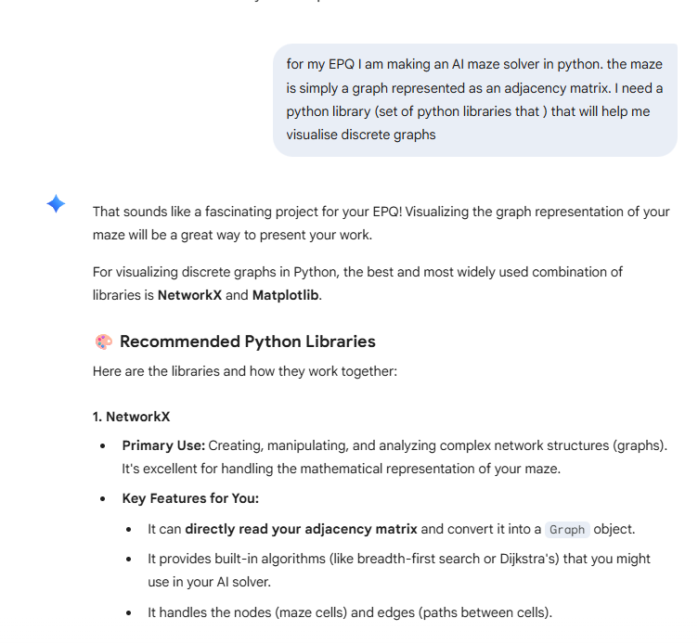
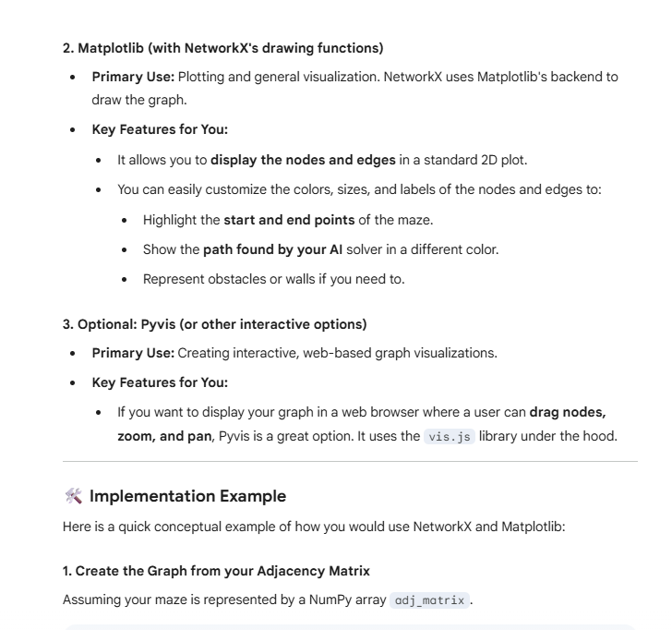
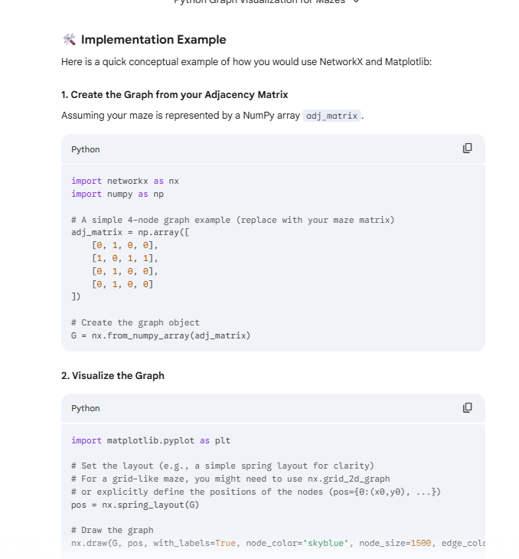
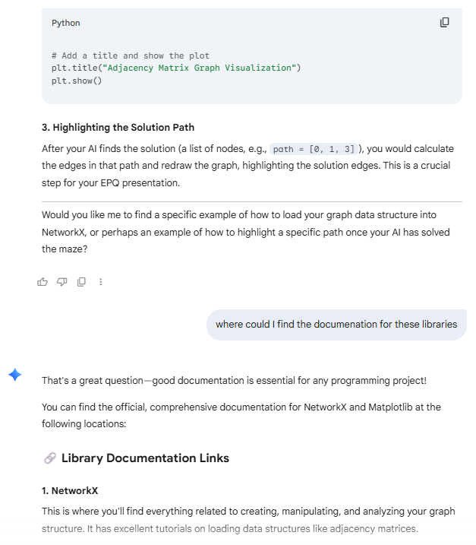
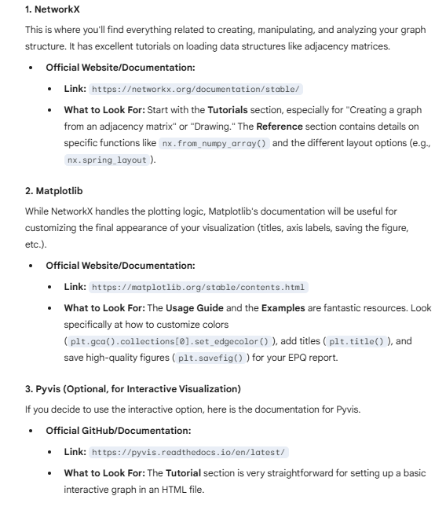
As you can see, Gemini played a crucial role in helping me discover the libraries that I needed to create the UI visualisation. By conversing with the LLM longer, I was able to obtain the links to the documentation where I could conduct further research on my own. This additional research that I did was critical because the use of LLM’s has some large flaws:
- Gemini can firstly provide unreliable data (hallucinations.) This is because, similar to the nature of this project, the AI generates its responses on a statistical basis rather than a factual basis. Not verifying this data especially before adding any code to my program could be detrimental to my progress and could break my program .
- Furthermore, Gemini gathers its data from large datasets based from the internet, so by directly copying from Gemini, I would be effectively copying from these sources, hence I would be plagiarising. This is a serious issue and could cause my EPQ to be rejected.
- A smaller issue is to do with indirect prompt injection. LLM’s are prone to high-level attacks where an LLM like Gemini accesses malicious code written by a hacker which it then accidentally provides to users like myself. If I were to copy and paste the code given by Gemini, there is a chance I could damage my computer.

